ADMINISTRATION & CONFIGURATION (LEVEL 7)
- User Roles & Permissions
- User Management
- Project-Level Settings
- Custom Statuses
- Custom Templates
- Workflow Customization

1. User Roles & Permissions :
A Role defines: What actions a user can perform in TestRail. Permissions prevent:
- Accidental deletions
- Unauthorized changes
- Audit violations
Role | Access Level
Administrator | Full control
Test Lead | Project + planning
Tester | Execution only
Read-only | View reports

Common Permissions :
- Create/Edit test cases
- Execute tests
- Add test runs/plans
- Modify templates
- View reports
Permissions should follow least privilege principle. User roles protect data integrity and ensure audit compliance.

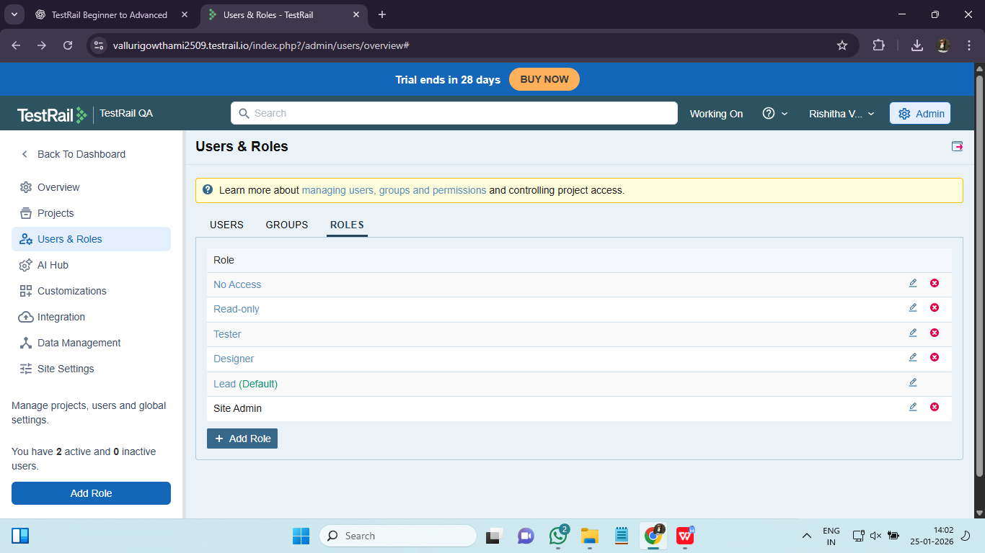

2. User Management :

User Management is a process of managing:
- Who can access TestRail
- Which projects they see
- What role they have

User Types :
- Internal testers
- External vendors
- Stakeholders (read-only)
- Disable users instead of deleting
- Use read-only for audits
- Separate admin accounts
User management directly impacts security and traceability.

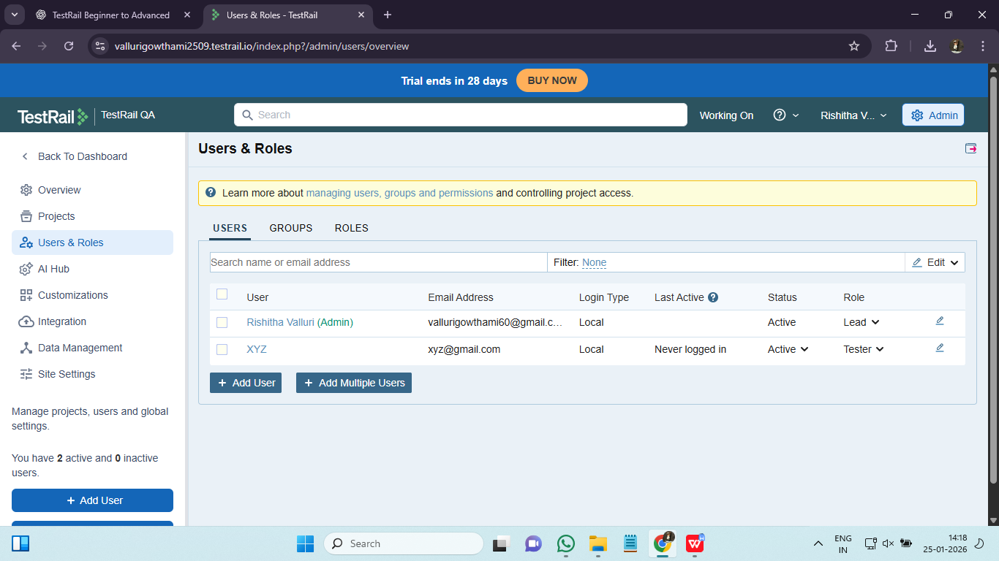

3. Project-Level Settings :
Project level settings define configurations specific to a project, not global.

These Can Be Configured :
- Project type (Single / Multiple suites)
- Enabled features
- Defect integration
- Milestones
- Automation settings
Project-level settings allow different workflows for different products.
Example:
Agile project → frequent milestones
Maintenance project → minimal changes
Project settings align TestRail behavior with project methodology.

4. Custom Statuses :
Statuses represent execution outcome.
Default statuses are:
- Passed
- Failed
- Blocked
- Retest
- Untested
We need customized statuses because real projects need: Deferred, Not Applicable, Known Issue, Environment Issue
Status type affects reporting.Custom statuses improve execution accuracy and reporting clarity.
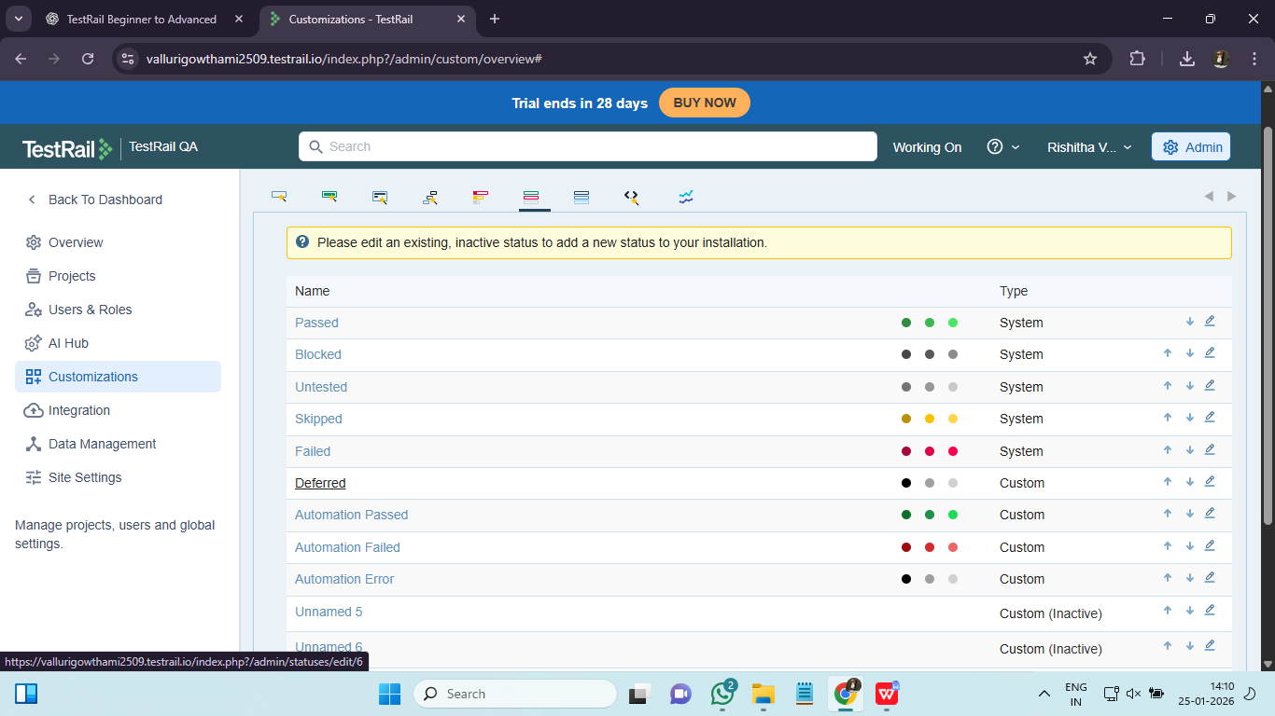

5. Custom Templates :
A Template defines test case structure. It includes : Fields, Layout, Mandatory attributes. We need custom templates because different test types need different data:
- Manual testing
- Automation-ready tests
- UAT cases
Templates enforce consistency across large teams.

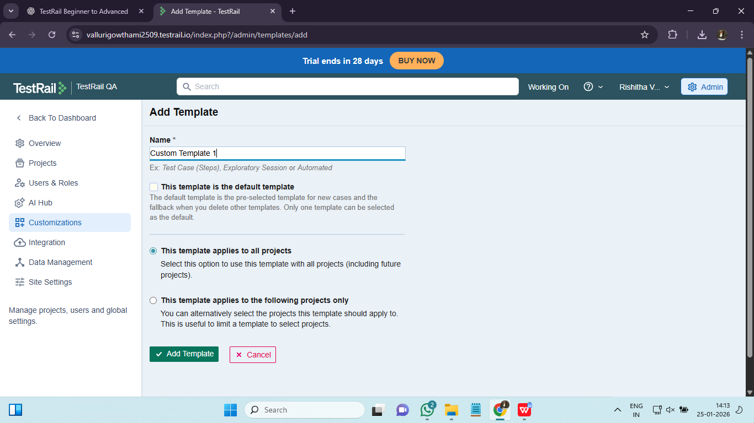

6. Workflow Customization :
Workflow customization defines How test cases move from Untested → Final state

Default Workflow :
Untested → Passed / Failed / Blocked → Retest → Passed

Why Customize Workflow?
- Match organizational QA process
- Reduce incorrect status usage
- Improve reporting accuracy
Advanced Workflow Example :
Untested
→ In Progress
→ Failed
→ Known Issue
→ Retest
→ Passed

Workflow customization aligns TestRail with real QA life cycles.

